**Finding Your Client Niche**

**To find a niche for your firm you will need to do some research but when you complete that research it will have huge benefits.**

**Top benefits of defining a niche:**

* Focus and clarity of your marketing messaging
* Consistency in your processes and procedures
* Lower learning curve for yourself and your staff
* Compatible software and tools that allow for efficiency
* Increased potential of more referrals and new clients
* Premium pricing for a knowledgeable brand identity

**Things to consider when identifying a niche**:

* Financial Factors - can this audience generally afford your services
* Cashflow - what are the cashflow habits of this potential audience (if they have a seasonal business your cashflow may not be steady)
* Sphere of influence - how likely are they to have relationships with others that could become new clients

Here is an example of an exercise that we did to help us clarify that the niche audience for the [www.TLTurnerGroup.com](http://www.tlturnergroup.com) should be Law Firms (*see the additional pages for a template that you can use to complete this exercise for your own firm*):

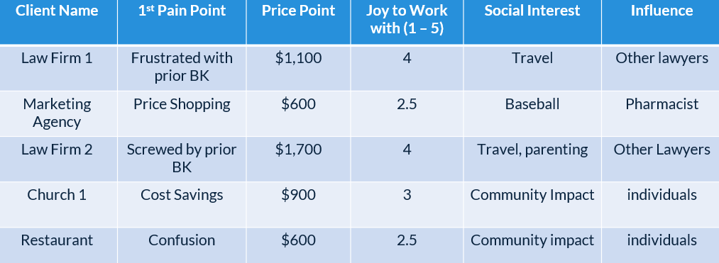

**To Use the template you can either:**

* Make a copy for yourself that you can edit or
* Download a copy in Microsoft Word that you can edit yourself

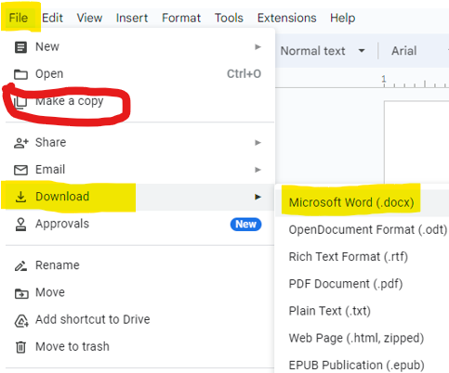

**Niche Finder Exercise instructions:**

* **List all of your clients** - if you have a really long list try to either: 1) Group them by some common sub-category, 2) List a portion of your clients and
* **1st Pain point** - what was the problem/pain that they were experiencing that made them want to work with you and your firm (for example: they were price shopping for a cheaper option, their prior accountant was making mistakes etc)
* **Price Point** - what is the average monthly or one-time price that they pay
* **Social Interest** - what types of things are they interested in
* **Influence** - what types of referrals could this client potentially connect you with (are these the types of clients that you want to work with)

| **#** | **Client Name** | **1st Pain Point** | **Price Point** | **Joy of Work**  **(1 - 5)** | **Social Interest** | **Influence** |
| --- | --- | --- | --- | --- | --- | --- |
| **1** |  |  |  |  |  |  |
| **2** |  |  |  |  |  |  |
| **3** |  |  |  |  |  |  |
| **4** |  |  |  |  |  |  |
| **5** |  |  |  |  |  |  |
| **6** |  |  |  |  |  |  |
| **7** |  |  |  |  |  |  |
| **8** |  |  |  |  |  |  |
| **9** |  |  |  |  |  |  |
| **10** |  |  |  |  |  |  |
| **11** |  |  |  |  |  |  |
| **12** |  |  |  |  |  |  |
| **13** |  |  |  |  |  |  |
| **14** |  |  |  |  |  |  |
| **15** |  |  |  |  |  |  |
| **16** |  |  |  |  |  |  |
| **17** |  |  |  |  |  |  |
| **18** |  |  |  |  |  |  |
| **19** |  |  |  |  |  |  |
| **20** |  |  |  |  |  |  |
| **21** |  |  |  |  |  |  |
| **22** |  |  |  |  |  |  |
| **23** |  |  |  |  |  |  |
| **24** |  |  |  |  |  |  |
| **25** |  |  |  |  |  |  |
| **26** |  |  |  |  |  |  |
| **27** |  |  |  |  |  |  |
| **28** |  |  |  |  |  |  |
| **29** |  |  |  |  |  |  |
| **30** |  |  |  |  |  |  |